HW1 E24066226魏晉成

1. Behavioral Model module

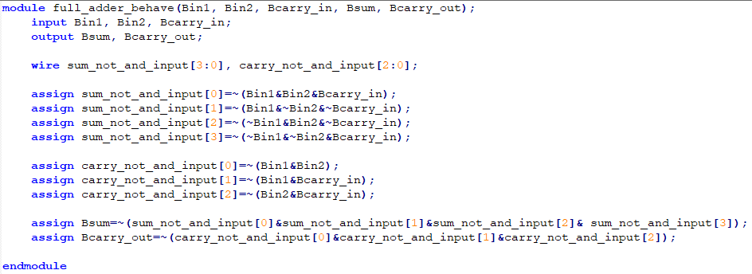

1. Structural Model module

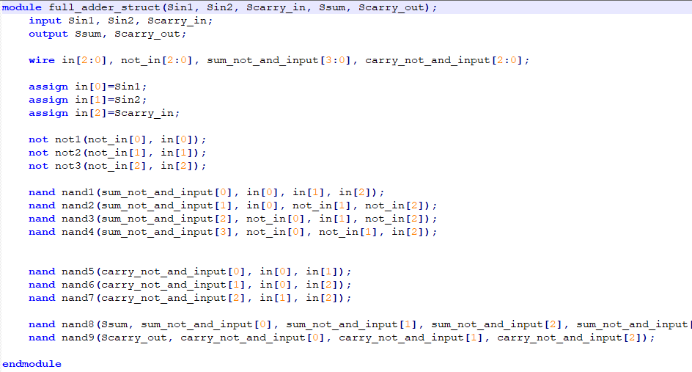

1. Test module for Behavioral Model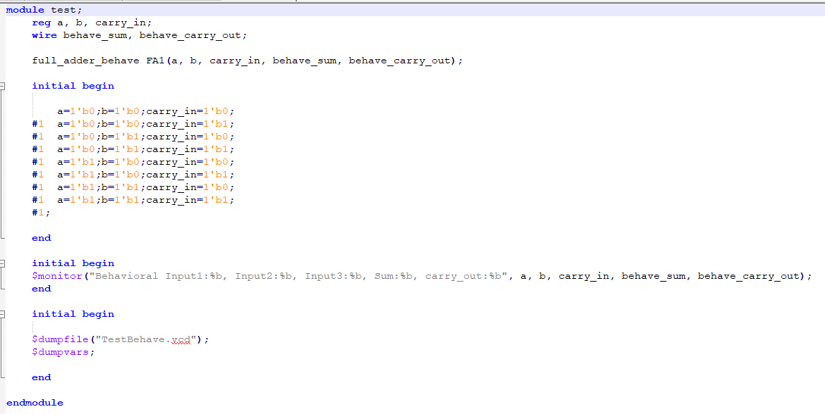
2. Test module for Structural Model

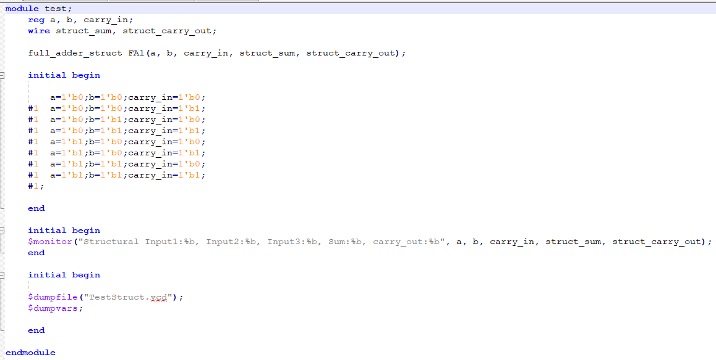

1. Output Wave of Behavioral Model

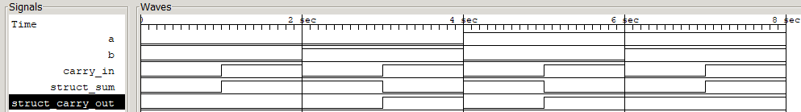

1. Output Wave of Structural Model